Longitudinal Analysis of Antidepressant Prescribing

The cost of antidepressant prescribing has fluctuated between 2021 and 2024, while the number of antidepressants prescribed has generally increased. To assist the NHS with decision-making surrounding antidepressants budgeting and mental health service provision, this report identifies sertraline hydrochloride antidepressants as the primary driver of prescription increases and cost fluctuations across all NHS regions, and identifies regions more deeply impacted by sertraline hydrochloride than others.

This report begins with an analysis of total antidepressant prescribing and total antidepressant cost across the four years, which provides context for additional analysis.

***National Total Annual Antidepressant Prescriptions and Antidepressant Prescribing Cost***

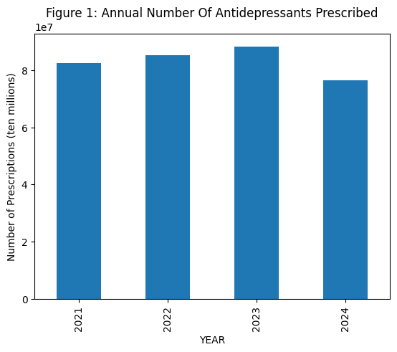

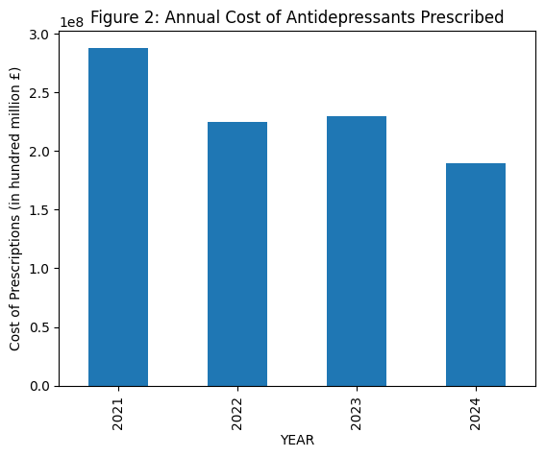

The annual total number of antidepressant prescriptions was above 80 million in 2021 and steadily rose until 2023. It then dropped below 80 million prescriptions in 2024. Meanwhile, the annual total cost of antidepressants began at approximately 280 million pounds in 2021 before dropping dramatically to approximately 230 million pounds in 2022. Although the total cost of prescriptions rose slightly in 2023, it proceeded to drop sharply again in 2024.

As expected, when the number of antidepressant prescriptions fell in 2024, the total cost of antidepressant prescriptions in 2024 also fell. When the number of antidepressant prescriptions rose in 2023, the total cost of antidepressant prescriptions also rose, albeit just slightly. However, the opposite occurred in 2022; while antidepressant prescriptions increased, the cost of antidepressant prescriptions fell by almost 50 million pounds.

In general, it appears that the annual cost of antidepressant prescriptions is on a downward trend, while the number of antidepressant prescriptions was on an upward trend before the number of prescriptions fell in 2024.

However, it is important to note that the data for 2024 is missing two months; it only includes January to October. The missing months likely contribute to the drop in number and cost of antidepressant prescriptions. This information must be noted and considered throughout the rest of the report.

***Regional Total Annual Antidepressant Prescriptions and Antidepressant Prescribing Cost***

*Table 1: Total Annual Number of Antidepressant Prescriptions For Each Region*

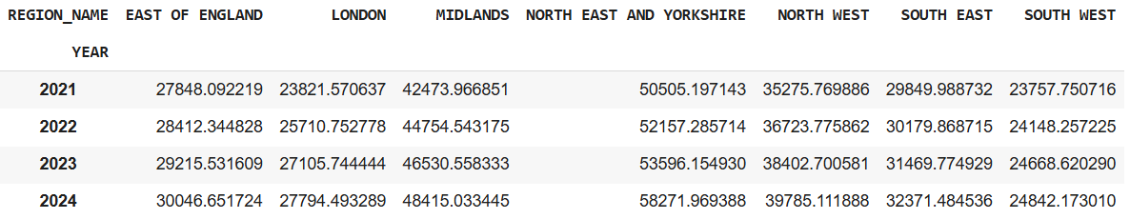

*Table 2: Total Annual Antidepressant Prescription Cost for Each Region*

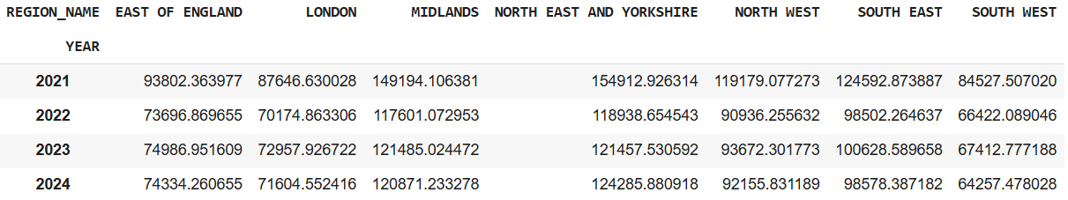

Overall, the number of antidepressants prescribed increased across all regions between 2021 and 2024. The region with the greatest change (range) is North East and Yorkshire, with the number of prescriptions growing by almost eight thousand between 2021 and 2024. The South West saw the smallest change, with the number of prescriptions growing by approximately one thousand between 2021 and 2024 (Table 1).

The cost of antidepressants saw an overall decrease across the four years. All regions saw a dramatic drop in cost of prescriptions from 2021 to 2022, then a smaller increase (typically 15,000 pounds) between 2022 and 2023 before dropping again. The North East and Yorkshire had the highest cost of prescriptions across the years 2021, 2022, and 2024; the Midlands had the highest cost of prescriptions in 2023 (Table 2).

Notice the cost of antidepressants decreased dramatically between 2021 and 2022, despite an increase in the number of prescriptions. The same occurs between 2023 and 2024, except in the North East and Yorkshire. The North East and Yorkshire is the only region where the cost of antidepressants increased between 2023 and 2024, likely because this region saw a significantly higher increase in antidepressant prescriptions (approximately 5000 more prescriptions) than others.

***Most Prescribed Antidepressants and Most Expensive Antidepressants***

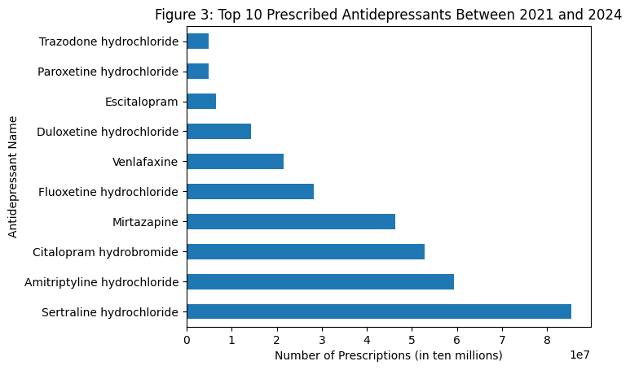

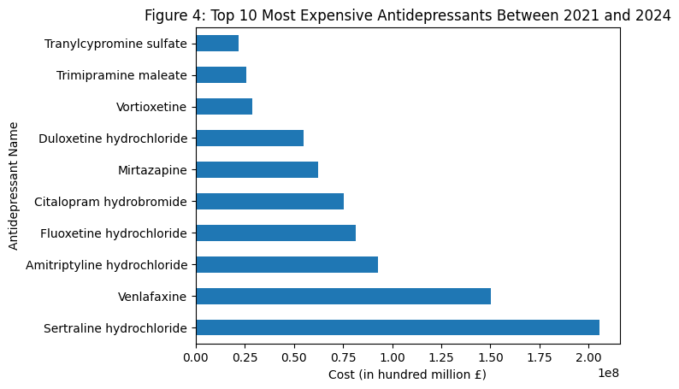

Sertraline hydrochloride is the most prescribed across the four years (Figure 3) and the most expensive across the four years (Figure 4). Surprisingly, Venlafaxine is the sixth most prescribed, yet second most expensive. Meanwhile, Mirtazapine is the 4th-most prescribed at approximately 47 million prescriptions across the four years, yet is 6th-most expensive at approximately 65 million pounds. Lastly, escitalopram, paroxetine hydrochloride, and trazodone hydrochloride are the 8th, 9th, and 10th most-prescribed, respectively, yet are not costly enough to make it to the top ten most expensive antidepressants chart. They are replaced by Vortioxetine, trimipramine maleate, and tranylcypromine sulfate.

***Longitudinal Analysis: Identifying Drivers of Cost and Prescription Numbers***

To identify the antidepressant drugs that are driving monthly item and cost trends, this report focuses on the top ten most prescribed antidepressants and top ten most costly antidepressants as listed in the previous section. This is because it is unlikely for other antidepressants to have a significant impact on prescription number or prescription cost, as shown by Figure 5 and Figure 7 below. From Figure 5, it is apparent that the top ten most prescribed antidepressants have always been the most prescribed between 2021 and 2024. From Figure 7, although the cost of certain antidepressants have fluctuated greatly, these wildly-fluctuating costs are also in the top ten most expensive antidepressants. Hence the following line graphs will be filtered to show only the top ten most-prescribed and most-costly antidepressants, creating a cleaner and clearer picture of the trends in Figure 6 and Figure 8.

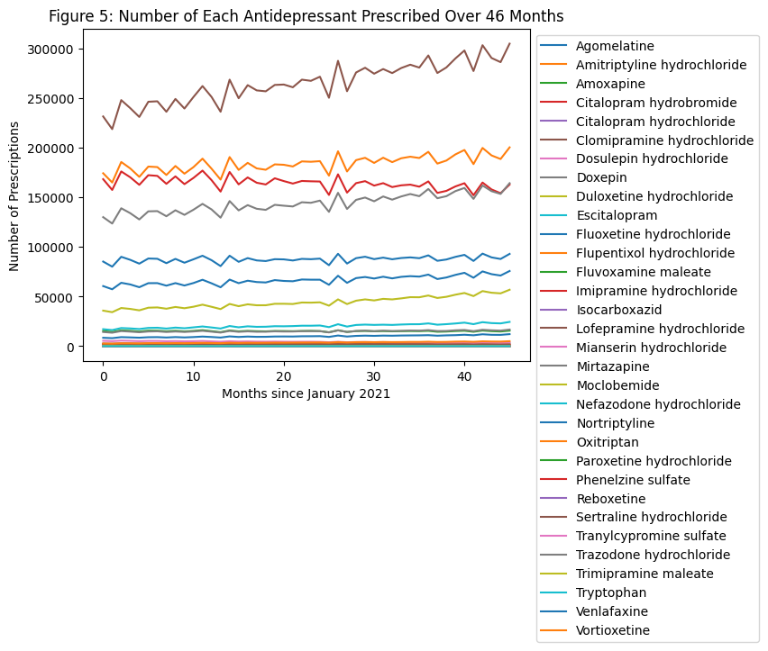

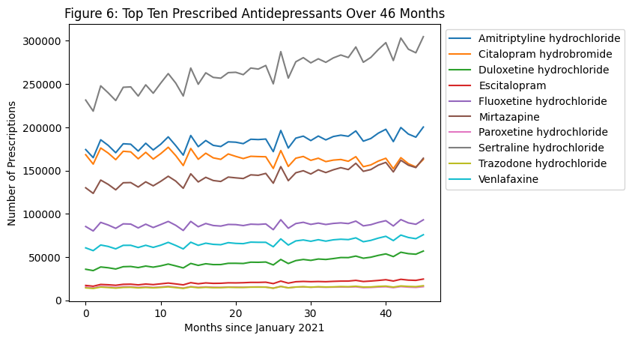

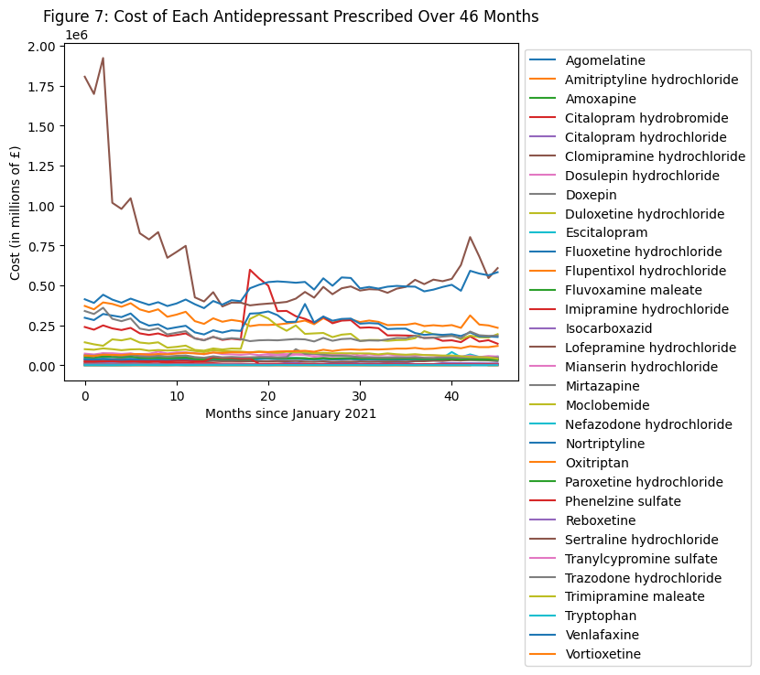

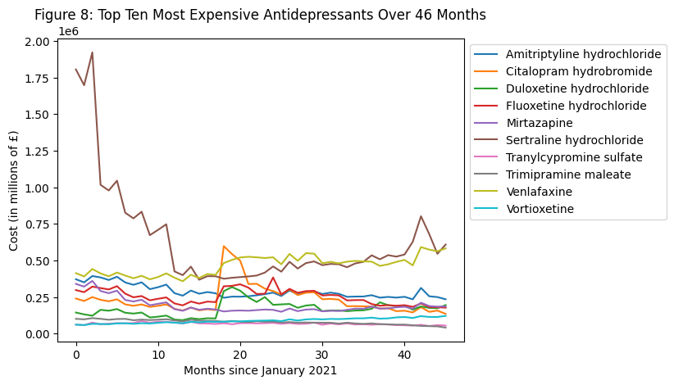

Based on the information in Figure 7, sertraline hydrochloride is the primary driver of antidepressant prescription count. Over four years, the number of sertraline hydrochloride prescriptions has increased overall, from approximately 235,000 prescriptions in 2021 to approximately 300,000 prescriptions by 2024. Amitriptyline hydrochloride is the secondary driver of antidepressant prescriptions, though the number of amitriptyline prescriptions has remained relatively stable across the four years compared to sertraline hydrochloride. Lastly, the number of citalopram hydrobromide prescriptions has begun to fall, but the increase in Mirtazapine prescriptions compensates for its decrease.

As a result, recent months show that sertraline hydrochloride is the main contributor to the number of antidepressant prescriptions, but amitriptyline hydrochloride and Mirtazapine are also contributors that are growing in prominence.

Figure 8 reveals the significant impact sertraline hydrochloride has on the cost of antidepressant prescriptions. The dramatic drop in the cost of antidepressants between 2021 and 2022 appears to be caused primarily by a fall in the cost of sertraline hydrochloride, from approximately £1.8 million at the start of 2021 to approximately £400,000 at sertraline hydrochloride's lowest point in 2022. Notably, the total spent on Citalopram hydrobromide, fluoxetine hydrochloride, and Duloxetine hydrochloride also spiked in 2022, but has since fallen to more moderate levels.

Figure 8 shows that sertraline hydrochloride and Venlafaxine have recently been the main drivers of antidepressant prescription cost. The cost of most antidepressants have fallen since 2021 or their spike in 2022. However, the cost of sertraline hydrochloride has risen to £500,000 by the end of 2024. Similarly, the cost of Venlafaxine has risen from approximately £400,000 in January 2021 to approximately £500,000 in December 2024.

***The Impact of Sertraline Hydrochloride***

Since sertraline hydrochloride was identified as a primary driver of both cost of prescriptions and the number of prescriptions, the remainder of this report delves into the extent of the influence of sertraline hydrochloride over four years.

*Table 3: Annual Percentage of Sertraline Prescriptions With Respect to Total Prescriptions*

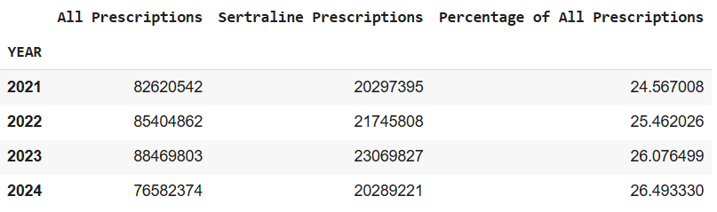

As shown by Table 3 above, sertraline hydrochloride prescriptions take up a large percentage of all antidepressant prescriptions. From 2021 to 2024, sertraline hydrochloride comprises approximately a quarter of all prescriptions, and the percentage is steadily rising.

*Table 4: Annual Percentage of Sertraline Prescription Cost With Respect to Total Cost*

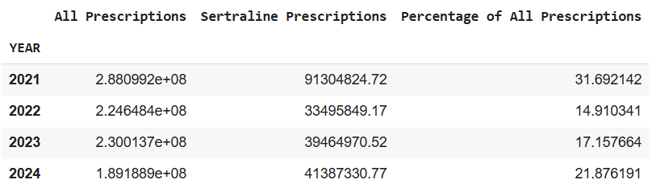

The cost of sertraline hydrochloride comprised almost one third (31.7%) of the cost of all prescriptions in 2021. This percentage then fell to 14.9% in 2022, but has since risen to 21.8% in 2024. The increasing trend from 2022 to 2024 corresponds with the increasing percentage of the number of sertraline hydrochloride prescriptions. However, it is worth investigating whether the cost of sertraline hydrochloride prescriptions is growing faster than the number of sertraline hydrochloride prescriptions.

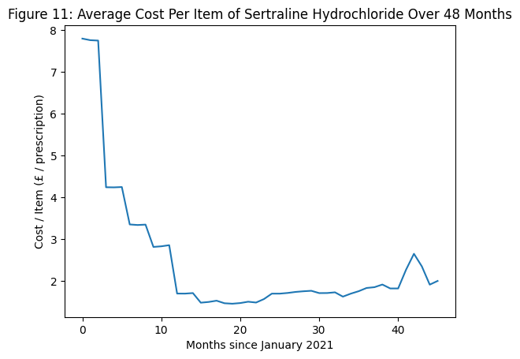

Based on Figure 11, the cost per unit of sertraline hydrochloride dropped sharply throughout 2021. Since then, the cost per unit has been slowly increasing, with a sudden spike in 2024. This shows that the cost of sertraline hydrochloride has recently been increasing faster than the number of sertraline hydrochloride prescriptions, which may affect or place financial strain on individuals who use sertraline hydrochloride.

Identifying regions where the number and cost of sertraline hydrochloride prescriptions has grown the fastest may help the NHS plan and budget for prescriptions and mental health resources. While each region has similar trends in the number of sertraline prescriptions over the four years, the North East and Yorkshire and the Midlands have a much higher number of prescriptions than other regions (Figure 12). Most importantly, Figure 12 reveals that the rate of growth of prescriptions in the North East and Yorkshire and the Midlands between 2021 and 2024 is also much higher than that of other regions. The number of sertraline hydrochloride prescriptions in the North East and Yorkshire increased by almost 150,000 prescriptions across the 46 months, while the number of prescriptions in the Midlands increased by almost 100,000 prescriptions. In other regions, the increase is less than 50,000 prescriptions over the four years.

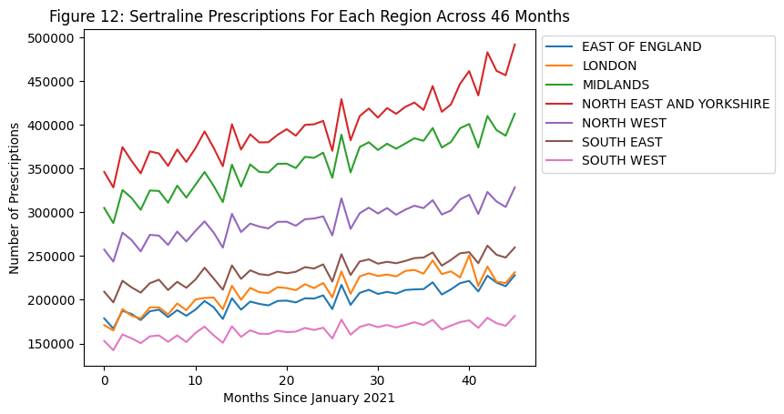

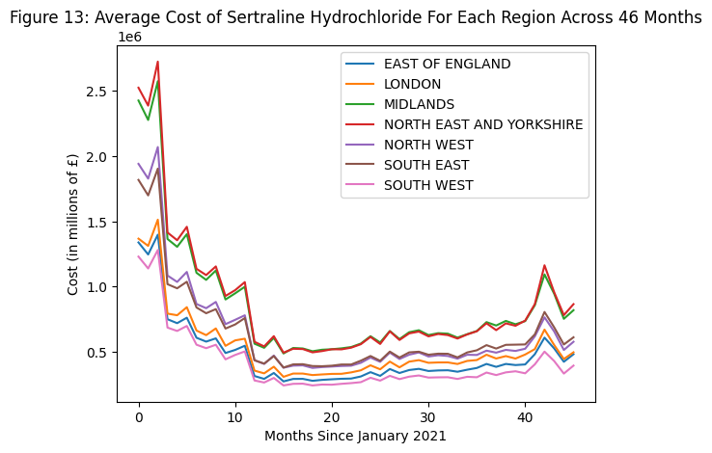

The cost of sertraline hydrochloride also follows similar trends across all regions; the cost falls and rises at similar rates across the 46 months (Figure 13). The Midlands and the North East and Yorkshire generally spend the most on sertraline hydrochloride prescriptions. Surprisingly, it appears that the South East spends more on sertraline hydrochloride prescriptions than the North West (Figure 13), despite the North West having approximately 50,000 more sertraline hydrochloride prescriptions than the South East each month (Figure 12). Besides this inconsistency, the order of sertraline hydrochloride prescription numbers matches the order of sertraline hydrochloride prescription costs. Regardless, it will be informative to perform longitudinal analysis on the cost per unit of sertraline hydrochloride for each region.

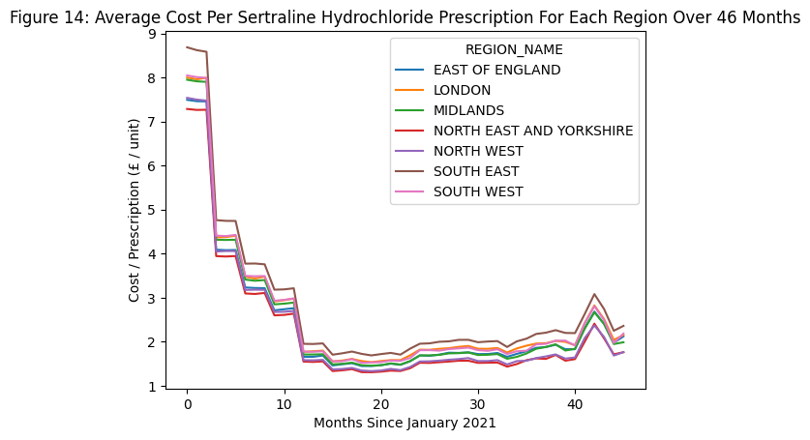

The trend of average cost per prescription of sertraline hydrochloride is remarkably similar across all regions. The drop in cost per prescription in 2021 matches the drop in overall cost as seen in Figure 13. However, Figure 14 shows that the average cost per prescription of sertraline hydrochloride has been consistently higher for the South East compared to other regions. Meanwhile, the North East and Yorkshire has one of the lowest average cost per prescription of sertraline hydrochloride, despite having the highest number of and greatest spending on sertraline hydrochloride prescriptions.

***Summary and Conclusion***

The annual number of prescriptions generally increased from 2021 to 2023, but fell in 2024. Meanwhile, the annual cost of prescriptions fell dramatically between 2021 and 2022, increased slightly, then fell again between 2023 and 2024. The decreases in prescription number and prescription cost between 2023 and 2024 may be because the dataset only contains ten months of data for 2024, while the other years contain all twelve months. Taking the missing months into account, it is reasonable to assume that antidepressant prescriptions and costs will continue to grow in 2024 and beyond.

A breakdown of the specific antidepressants prescribed shows that sertraline hydrochloride is a primary driver of both total antidepressant prescriptions and total antidepressant costs. Every year, it accounts for a higher percentage of total prescriptions and costs. The average cost of sertraline hydrochloride itself is also growing each year, and can be expected to continue growing in the future.

Examining the cost and numbers of sertraline hydrochloride prescriptions across regions shows that the South East has a higher cost per prescription of sertraline hydrochloride. The reasons for this higher cost are worth investigating in future reports and analysis. Additionally, the Midlands and the North East and Yorkshire are seeing significant growth in the number of sertraline hydrochloride prescriptions, suggesting that more mental health resources could be deployed in those regions. Future studies should focus on antidepressant numbers and costs in specific regions within the Midlands and the North East and Yorkshire, identifying with more specificity the locations that require more resources.